**Chapter 4: DETAILED DESIGN**

**4.1: Home Page**

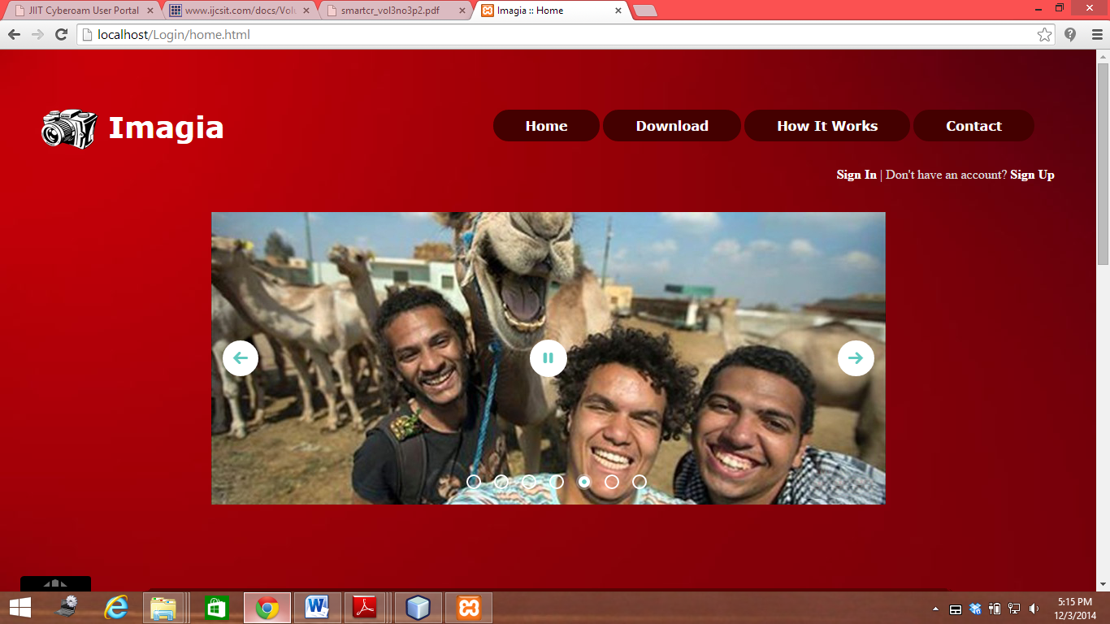

This is the first screen that tells the user the benefits of the software and shows all tabs that are available to the user.

**4.2: Login**

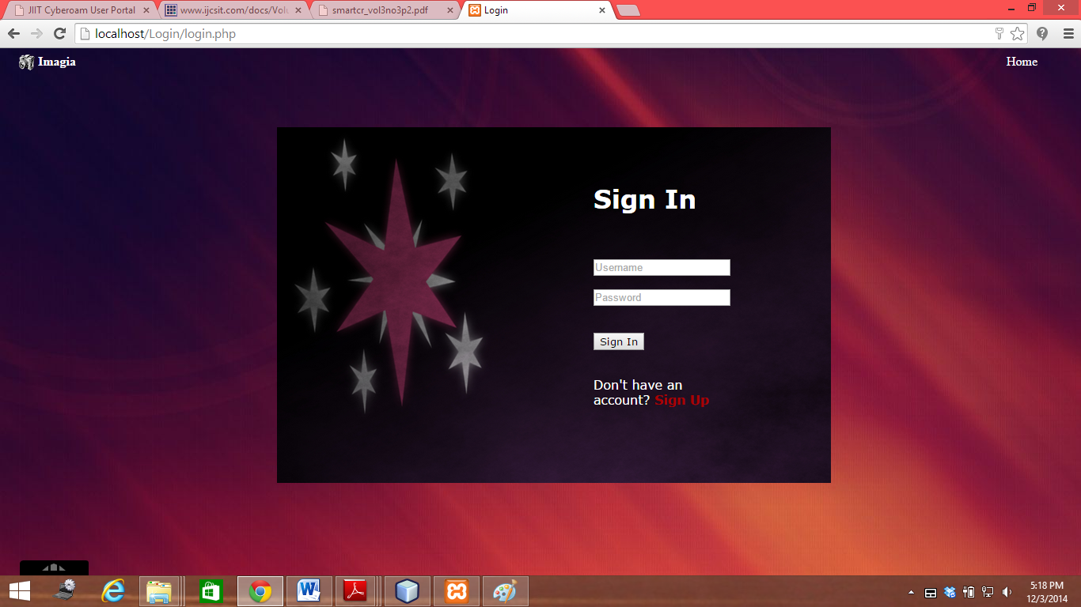

Here user have to Login before Download.

**4.3: Sign up**

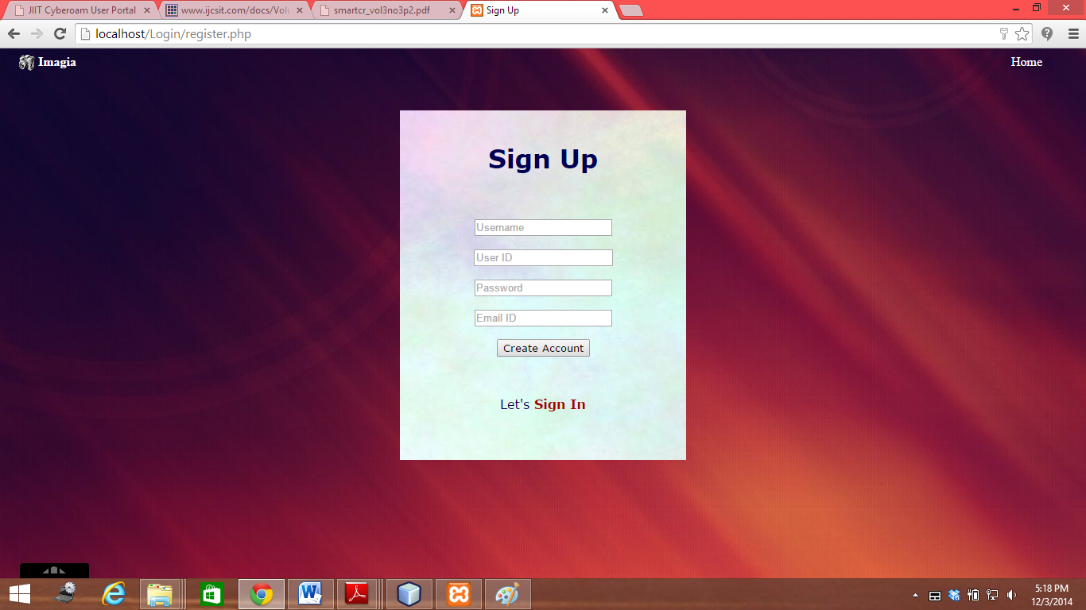

Here user has to Sign Up if he/she hasn’t any account.

**4.4: Download**

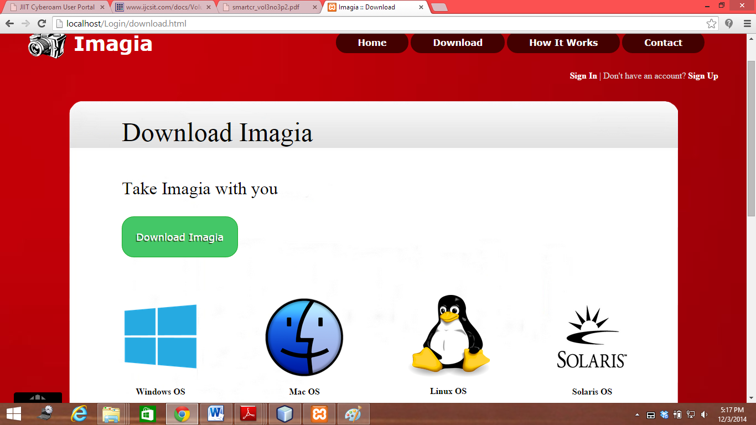

User can download their software from here.

**4.5: About**

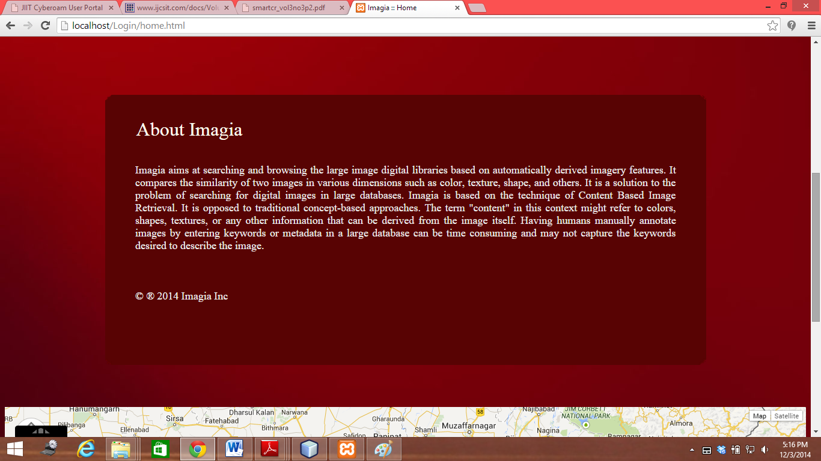

This describes the properties of Imagia.

**4.6: Contact Page**

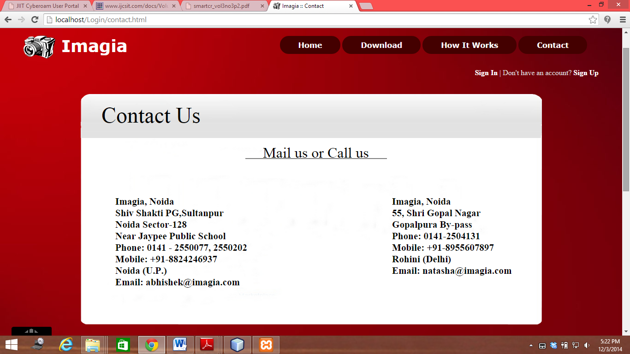

Here user can contact us.

**4.7: Software search panel**

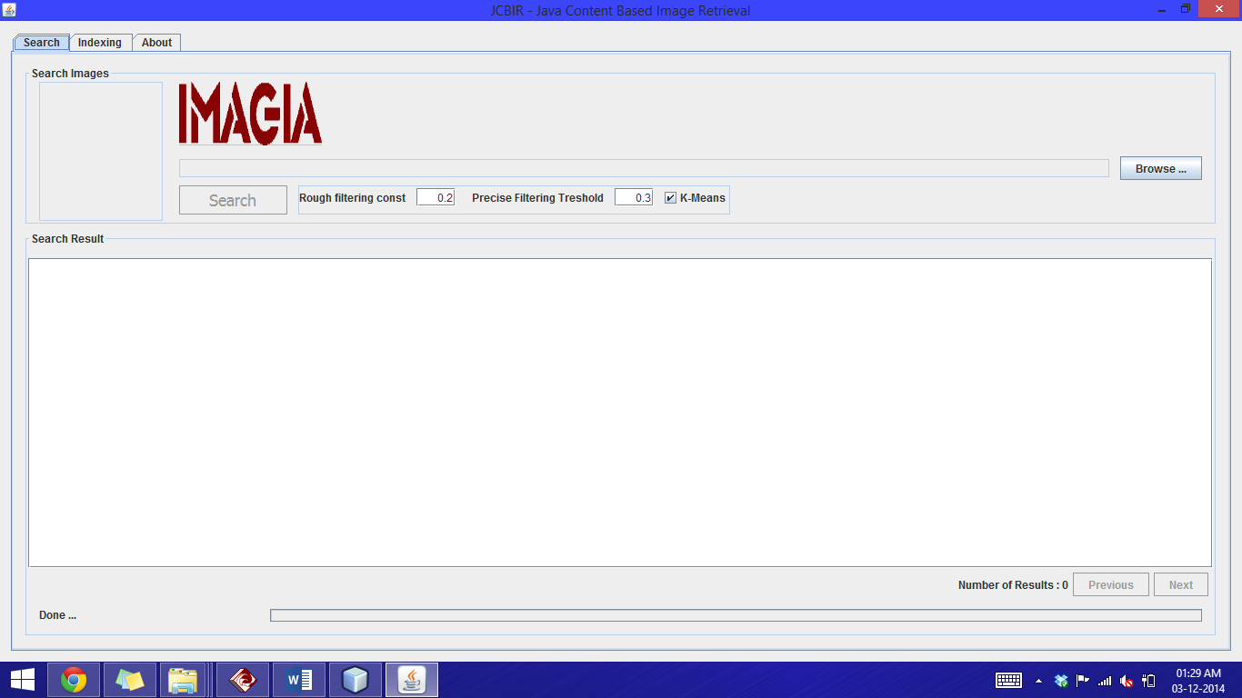

**4.8: Software indexing panel**

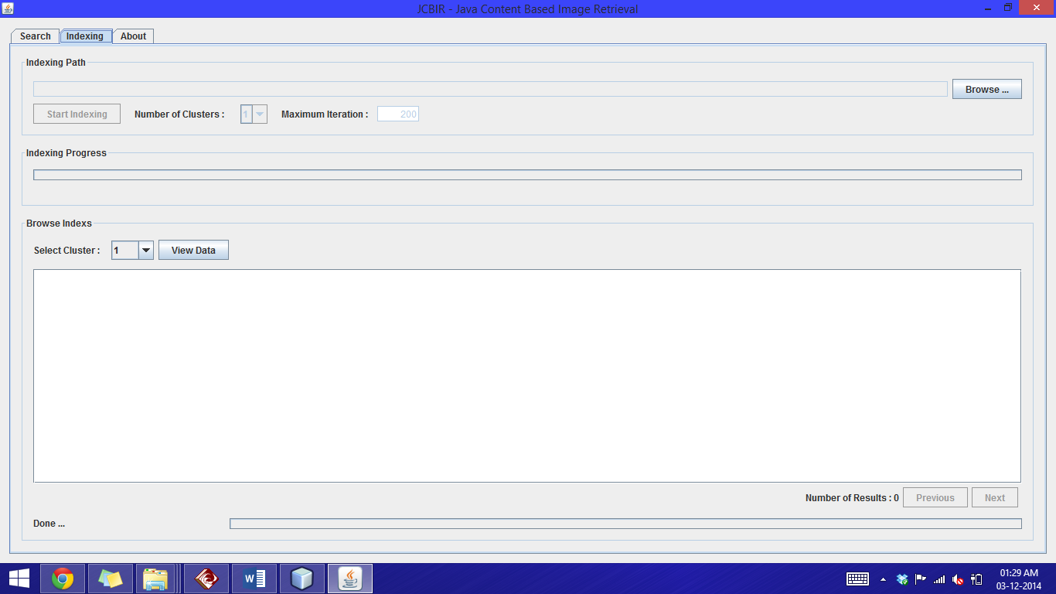

**4.9: Software about panel**

